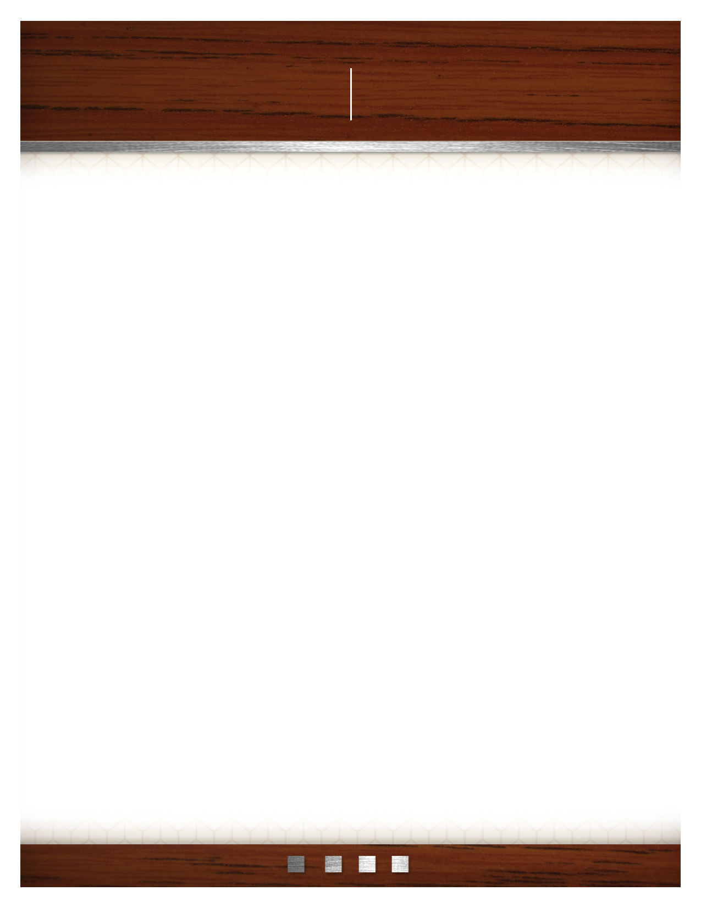
Insert logo or company name here
SUBHEAD GOES HERE

Begin your letter here.
Phone: 555.555.5555 Fax: 555.555.5555
555 Street Address City, State 55555
www.webaddress.com

