



[Your Company’s Name]

[Title]
A Proposal to
[Client Name]

Presented on
[Date]

[You can include a proprietary notice that sets conditions for the sharing and copying of this document.]

Table of Contents
[Readers almost always look first at the table of contents to see how the proposal is structured. Make sure that all headings are easy to read, intuitive, and in a logical order.]

1 Current Situation 3
2 Solution 3
2.1 Objectives 3
2.2 Approach 3
2.3 Benefits 3
3 Implementation Plan 4
3.1 Methodology 4
3.2 Schedule 4
3.3 Resources 5
3.4 Qualifications 5
4 Costs 5
5 Conclusion 6
Appendix A: Examples of Appendices 7
Appendix B: Terms and Conditions 9

Introduction

[This section formally introduces your company and its proposed solution to the client. Include a brief summary of your company’s background, capabilities, and strategy in delivering value to the client. If you have a strong value proposition, you can include it here and note what it means to the client.]

Current Situation
[This column can be used to highlight key statements, quotes, statistics, or graphics. It also provides space for the client to write comments on a printed version of the document.]
[Use this section to clearly re-state the client’s primary business needs, problems, or opportunities. Try to add additional insights that prove your understanding of the industry and the unique challenges being faced by the client. Then explain the benefits of effectively addressing these needs or opportunities and why your company is well positioned to deliver the desired benefits. Keep this section brief and to the point.]

Solution
[This section is used to outline your company’s proposed solution. The key here is to stay focused on the client’s requirements and show why your approach should be selected over other available options, including an in-house solution. Use statistics, if available, to further strengthen your message.]

Objectives
[Clearly describe the most important business objectives that will help solve the client needs or problems (three to five is optimal). Emphasize how your company has the experience and insights to address these objectives based on your expertise and past client successes.
- Objective 1
- Objective 2
- Objective 3]

Approach
[Use this section to describe the proposed solution strategy and the management approach your company will take in supporting the strategy. Explain this in words that the client can easily understand without being too technical or overlapping your implementation plan, covered in the next section of this document. Provide enough detail to distinguish your approach from other competitors without revealing everything up front.]

Benefits
[Describe the client benefits that will be realized as a result of your solution and your company’s expertise in implementing that solution. Wherever possible, try to quantify the benefits in terms of time, cost, or resources. If you can cite return on investment (ROI) findings for this type of solution, definitely do, but be prepared to verify any metrics if challenged by the client. As for the more intangible benefits, try to keep the client’s perspective in mind and stay focused on business value.

- Benefit 1
- Benefit 2
[When making a key statement in the proposal, consider highlighting it as a stand-alone sentence or quote in this column.]
- Benefit 3]

Implementation Plan
[While the previous section was primarily strategic, this section focuses on tactics and execution. Your goal is to build the client's confidence that you can deliver the desired solution and benefits as promised.]

Methodology
[Briefly discuss the methodology your company will use to implement the proposed solution. The methodology could relate to project management, systems development, or any relevant lifecycle used to ensure consistency and repeatability of your solutions (and still cater to the unique needs of the client). If you have additional information or graphics on this subject that will help distinguish you from your competitors, consider attaching them as an appendix.]

Schedule
[Never underestimate the importance of project management to the client. It can be a key differentiator when competitors are evenly matched. Emphasis here should be on timing and sequencing of major activities, deliverables, and milestones.
An effective way of tying all of these pieces together is to display a high-level project plan using Microsoft Office Project or some other project management tool. This helps the client to visualize your solution, while reinforcing your company’s expertise in project management. The trick is showing enough to educate the client without revealing your entire game plan.]
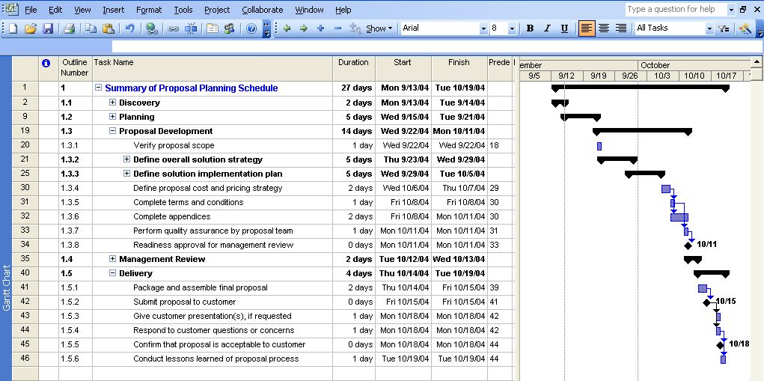
[Figure 1. Solution Project Plan. A Microsoft Office Project screen print provides the client with a high-level overview of the solution and conveys timing, sequencing, and dependencies of key activities.]


Resources
[Depending on the nature of the proposal, you may want to identify key resources that will be involved in the solution implementation. These can include people, materials, and facilities. Provide only the information that will be helpful to the client in evaluating your proposal. One option is to include a one-paragraph summary of the background of key managers, consultants, technical experts, and so on. Full resumes can always be attached as an appendix, if desired.]
[Use graphics that make the proposal more visually interesting. The photos in this template come from the Microsoft Media Gallery, available on the Microsoft Web site.]

Qualifications
[This is an opportunity to tell why your organization is uniquely qualified to deliver the solution as promised. Some considerations include: (1) your company’s track record in successfully implementing similar solutions; (2) formal industry or quality certifications such as ISO 9000, ISO 9001, and Six Sigma; and (3) individual certifications of key staff. Include only enough information to validate your capabilities. Use an appendix if you want to highlight your qualifications.]

Costs
[Now that the client understands your solution strategy and capabilities, you can describe your solution costs. How much detail you provide depends on your pricing strategy—whether it is a fixed price contract, cost plus, or some other approach. In any event, you want to include enough information so that the client can weigh your costs against the value being delivered by you or other competitors. Common expense items include resource hours and rates; hardware, software, and other material costs; subcontractor fees; invoicing instructions; legal disclaimers; travel; and other reimbursable costs. A more formal description of terms and conditions can be covered in an appendix.]

Cost Schedule | [Title 2] | [Title 3] | [Title 4]
[Row Title]
[Row Title]
[Row Title]
Total
[Table 2. Name of Table. When adding or embedding tables, you can use the full column width without affecting the surrounding text.]

Conclusion
[This is an opportunity to briefly summarize the key points of your proposal (such as value proposition, solution strategy, and benefits). Every conclusion should have a strong call to action. What is the desired response by the client after reading your proposal? The tone should be confident and assertive without being overly aggressive, while opening the door for a mutually rewarding relationship. Even if you lose this particular opportunity, you want to position yourself as a future ally who can be counted on to deliver a high-value solution. You may also want to personalize this final section with signature blocks (names and titles) of most senior person sponsoring the proposal and an executive.]

Appendix A: Examples of Appendices
[Appendices provide supporting information that is helpful, but not critical, to the client’s evaluation of your proposal. This includes material that might otherwise be disruptive to the flow and momentum of the main proposal. The volume of material in the appendices should not be so much as to overwhelm the main body of the proposal, however. As a safety measure, you should never assume that every client decision maker or influencer will read the appendices. Ask yourself: If a key client evaluator did not read any of the appendices, would it leave a hole in my proposal strategy?]

[Figure 2. Description of Graphic. The above exemplifies that graphics can be inserted into an appendix to visually convey an important concept.]

[Likely candidates for an appendix:
- Reprints of news articles, press releases, and corporate announcements
- Relevant client case studies, success stories, references, and testimonials
- Company or individual certifications (referenced in the main proposal)
- Resumes or biographies of key players (referenced in the main proposal)
- Organizational charts
- Description of your formal solution methodology
- Company history and accomplishments
- Design specifications or diagrams
- Supporting financial spreadsheets
- Terms and conditions (see Appendix B)]

Appendix B: Terms and Conditions
[The amount of attention you give to formal terms and conditions depends on the size, complexity, and nature of the sales proposal. In some cases, you may include a brief summary under the “Costs” section of the main proposal. However, a high-stakes proposal might justify a separate appendix for this topic. Typical examples of terms and conditions are:
- Copyright and limitations on use.
- Warranties.
- Limitation of liability.
- Termination.
- Dispute resolution.
- Amendment to terms and conditions.
- Third-party rights.
- Applicable law.
- Disclaimer.]

