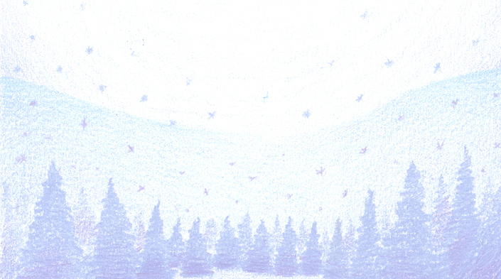
To: _______________________

From: _____________________
To: _______________________

From: _____________________
To: _______________________

From: _____________________
To: _______________________

From: _____________________
To: _______________________

From: _____________________
To: _______________________

From: _____________________
To: _______________________

From: _____________________
To: _______________________

From: _____________________
To: _______________________

From: _____________________
To: _______________________

From: _____________________
To: _______________________

From: _____________________
To: _______________________

From: _____________________
To: _______________________

From: _____________________
To: _______________________

From: _____________________
To: _______________________

From: _____________________
To: _______________________

From: _____________________
To: _______________________

From: _____________________
To: _______________________

From: _____________________
To: _______________________

From: _____________________
To: _______________________

From: _____________________
To: _______________________

From: _____________________
To: _______________________

From: _____________________
To: _______________________

From: _____________________
To: _______________________

From: _____________________
To: _______________________

From: _____________________
To: _______________________

From: _____________________
To: _______________________

From: _____________________
To: _______________________

From: _____________________
To: _______________________

From: _____________________
To: _______________________

From: _____________________

