
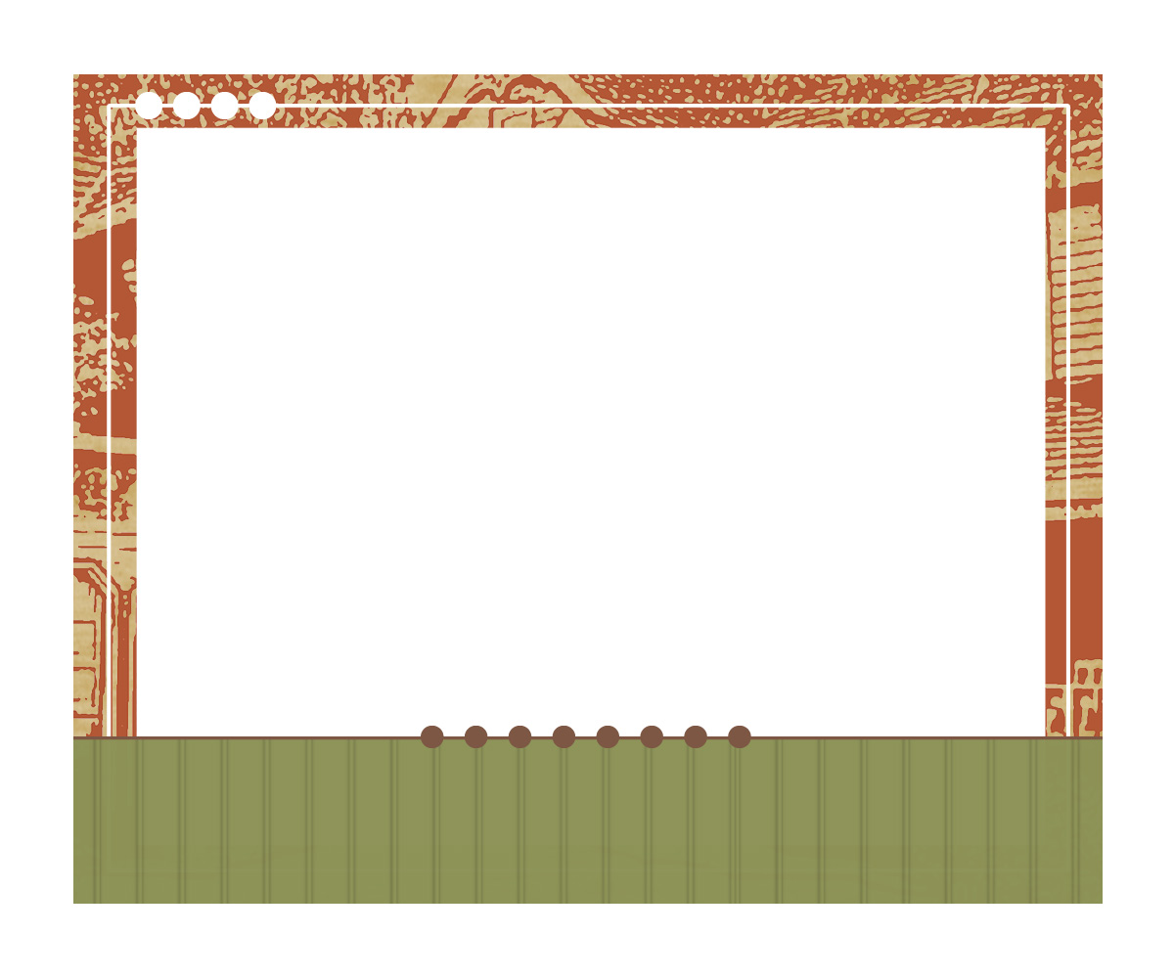
Insert Logo or Company name
5555 Street Address
City, State 55555

Company Name
Addressee
5555 Street Address
City, State 5555

Insert Logo or Company name
5555 Street Address
City, State 55555

Company Name
Addressee
5555 Street Address
City, State 5555
Insert Logo or Company name
5555 Street Address
City, State 55555

Company Name
Addressee
5555 Street Address
City, State 5555

Insert Logo or Company name
5555 Street Address
City, State 55555

Company Name
Addressee
5555 Street Address
City, State 5555

Insert Logo or Company name
5555 Street Address
City, State 55555

Company Name
Addressee
5555 Street Address
City, State 5555

Insert Logo or Company name
5555 Street Address
City, State 55555

Company Name
Addressee
5555 Street Address
City, State 5555

