
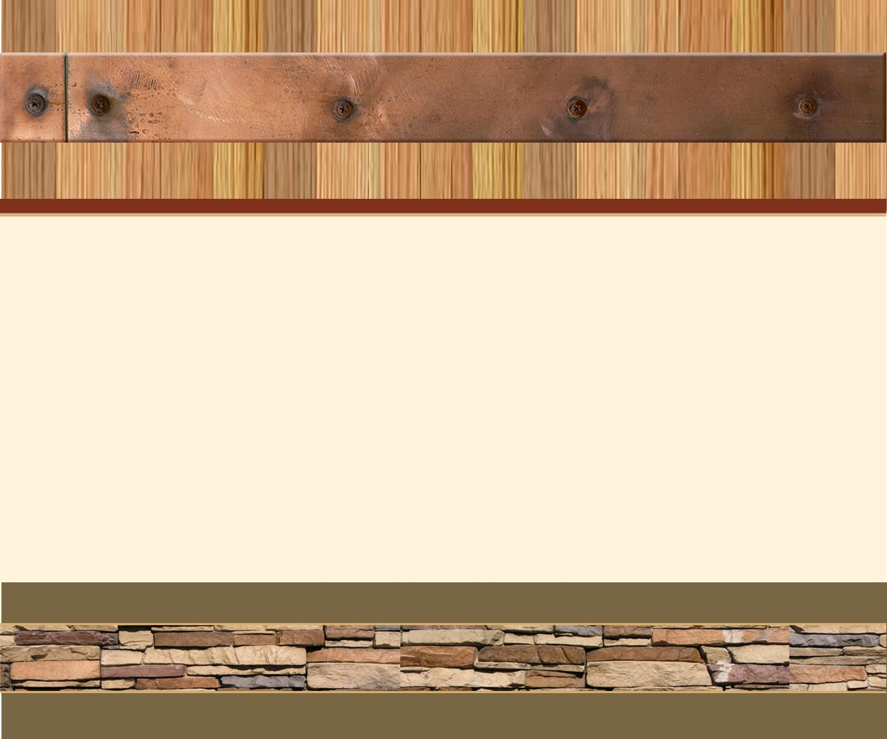
555 Street Address, Suite 555
City, STATE 55555
555.555.5555 office 555.555.5555 fax

Place logo
or logotype here.
Otherwise
delete this text.
SHIP TO: Shipping Address

555 Street Address, Suite 555
City, STATE 55555
555.555.5555 office 555.555.5555 fax

FROM: INSERT COMPANY NAME

555 Street Address, Suite 555
City, STATE 55555
555.555.5555 office 555.555.5555 fax

Place logo
or logotype here.
Otherwise
delete this text.
SHIP TO: Shipping Address

555 Street Address, Suite 555
City, STATE 55555
555.555.5555 office 555.555.5555 fax

FROM: INSERT COMPANY NAME

555 Street Address, Suite 555
City, STATE 55555
555.555.5555 office 555.555.5555 fax

Place logo
or logotype here.
Otherwise
delete this text.
SHIP TO: Shipping Address

555 Street Address, Suite 555
City, STATE 55555
555.555.5555 office 555.555.5555 fax

FROM: INSERT COMPANY NAME Here

555 Street Address, Suite 555
City, STATE 55555
555.555.5555 office 555.555.5555 fax

Place logo
or logotype here.
Otherwise
delete this text.
SHIP TO: Shipping Address

555 Street Address, Suite 555
City, STATE 55555
555.555.5555 office 555.555.5555 fax

FROM: INSERT COMPANY NAME Here

555 Street Address, Suite 555
City, STATE 55555
555.555.5555 office 555.555.5555 fax

Place logo
or logotype here.
Otherwise
delete this text.
SHIP TO: Shipping Address

555 Street Address, Suite 555
City, STATE 55555
555.555.5555 office 555.555.5555 fax

FROM: INSERT COMPANY NAME

555 Street Address, Suite 555
City, STATE 55555
555.555.5555 office 555.555.5555 fax

Place logo
or logotype here.
Otherwise
delete this text.
SHIP TO: Shipping Address

555 Street Address, Suite 555
City, STATE 55555
555.555.5555 office 555.555.5555 fax

FROM: INSERT COMPANY NAME

