
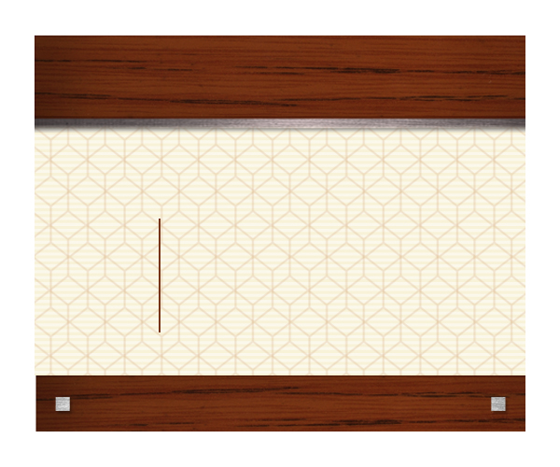
INSERT LOGO OR COMPANY NAME HERE

Company Name Here
Attention to Here
555 Street Address
City, State 55555
555 Street Address | City, State 55555
INSERT LOGO OR COMPANY NAME HERE

Company Name Here
Attention to Here
555 Street Address
City, State 55555

555 Street Address | City, State 55555

INSERT LOGO OR COMPANY NAME HERE

Company Name Here
Attention to Here
555 Street Address
City, State 55555

555 Street Address | City, State 55555

INSERT LOGO OR COMPANY NAME HERE

Company Name Here
Attention to Here
555 Street Address
City, State 55555

555 Street Address | City, State 55555

INSERT LOGO OR COMPANY NAME HERE

Company Name Here
Attention to Here
555 Street Address
City, State 55555

555 Street Address | City, State 55555

INSERT LOGO OR COMPANY NAME HERE

Company Name Here
Attention to Here
555 Street Address
City, State 55555

555 Street Address | City, State 55555

