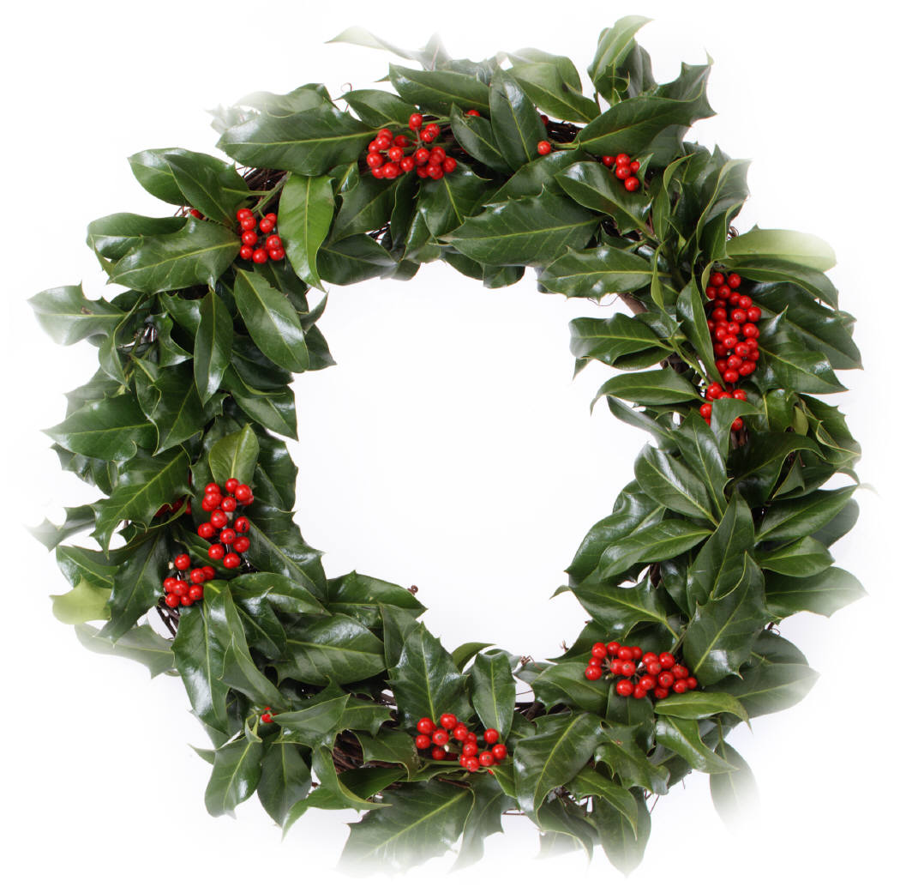
Happy Holidays
From Diana
To Roberto
With Love
Happy Holidays
From Diana
To Roberto
With Love

