Seed packet template (Final packet is 9.5 inches wide x 6 inches high)

Use text boxes or WordArt to add text to seed packet, making sure to keep text out of area on back indicated by grey lines. This area will be covered when the front panel is folded and pasted to back panel.
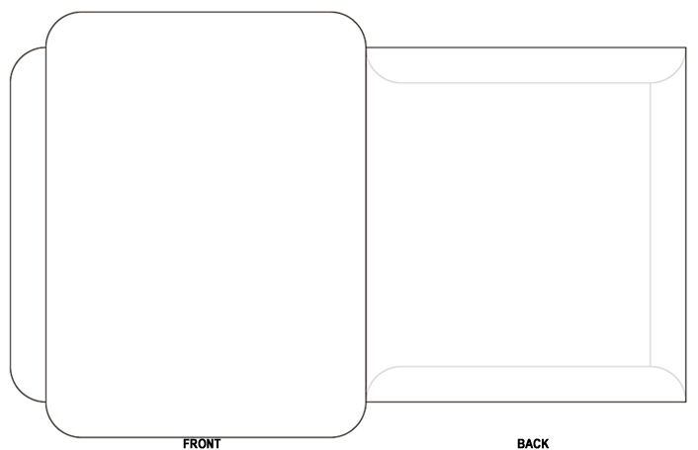

Click here to add additional text or photos.

Place seed instructions here

