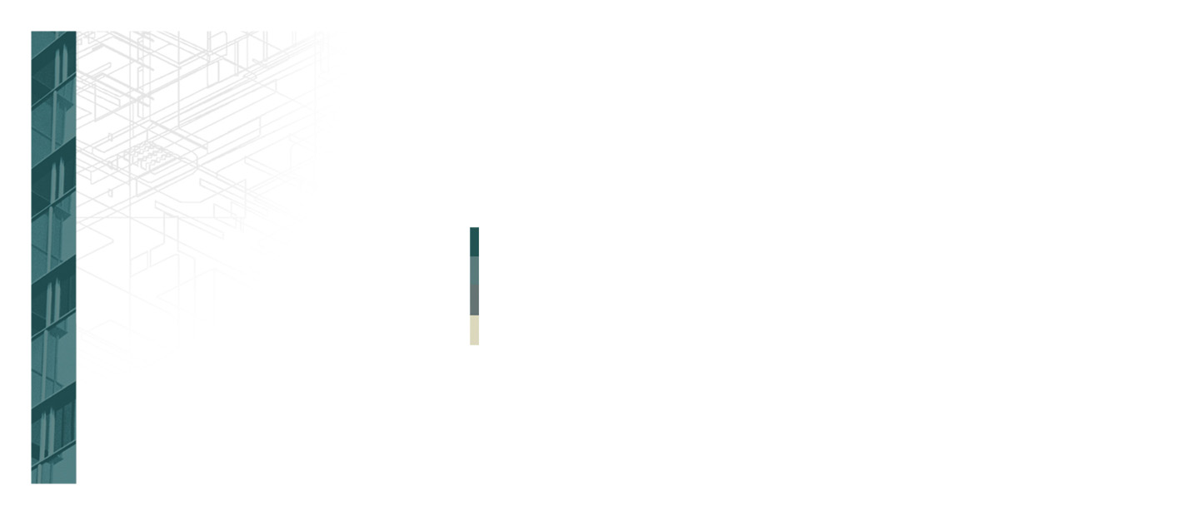
Insert Logo or
Enter Company Name
5555 Street Address
City, State 55555
Company Name
Recipient’s Name
5555 Street Address
City, State 5555

