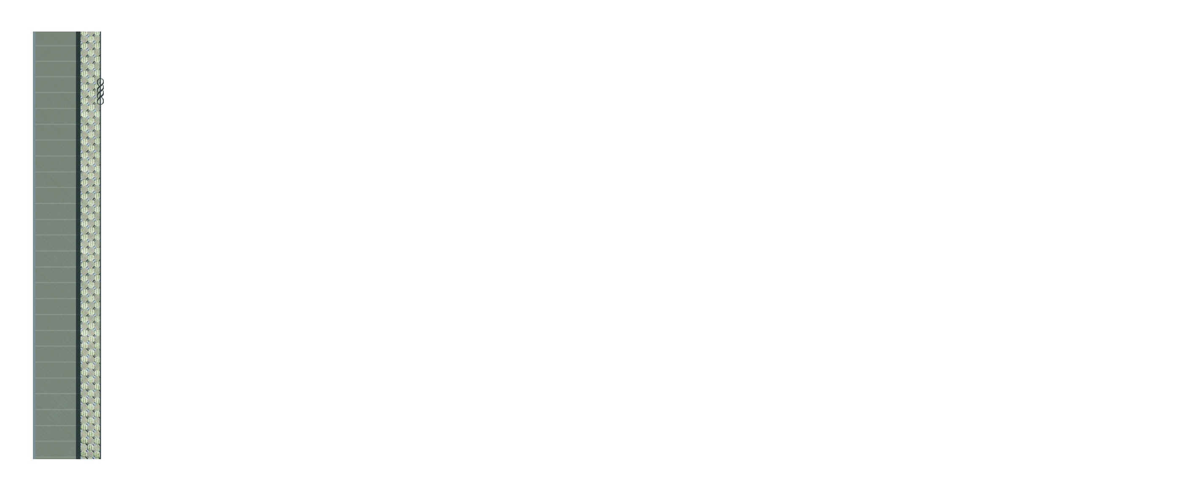
555 Street Address, Suite 555
City, STATE 55555

Insert Your Name
www.your-url-goes-here.com

555 Street Address, Suite 555
City, STATE 55555

Shipping Address

