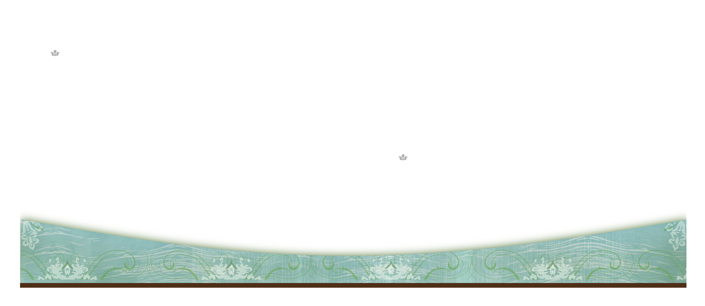
Insert Logo
Enter Company Name
555 Street Address
City, State 55555
Company Name
Recipient’s Name
555 Street Address
City, State 55555

