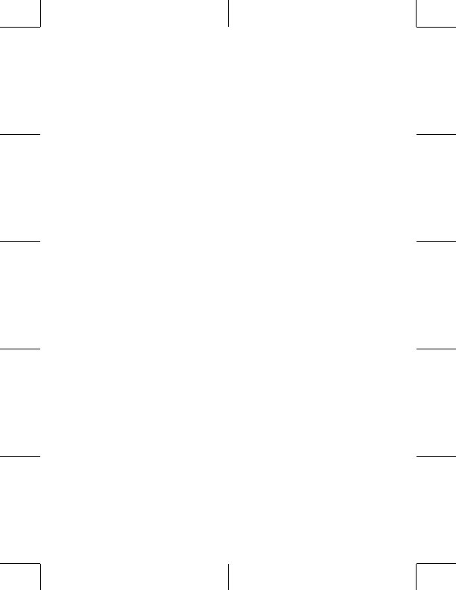
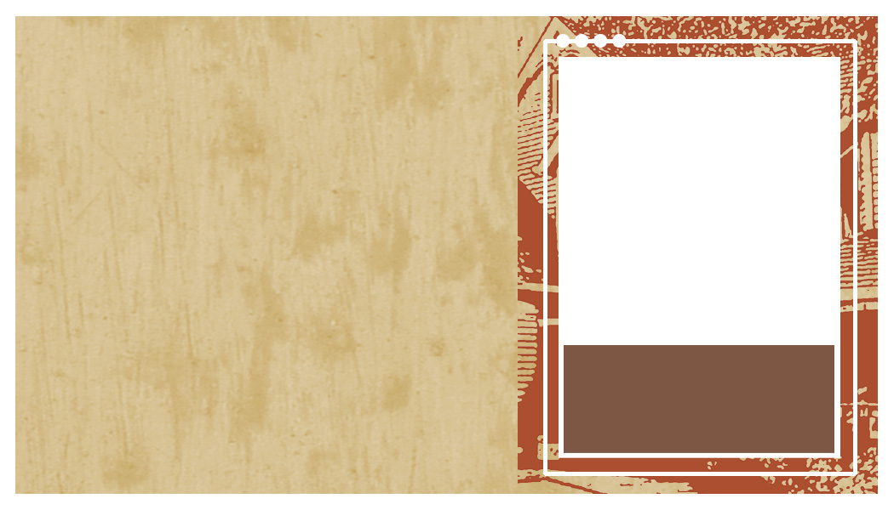
Your Name Here
LAST NAME HERE

telephone: 555.555.5555

facsimile: 555.555.5555

email: mail@youraddress.com

address: 5555 Street Address City, US, 55555

website: www.webaddress.com

Delete text and place photo here.
Your Name Here
LAST NAME HERE

telephone: 555.555.5555

facsimile: 555.555.5555

email: mail@youraddress.com

address: 5555 Street Address City, US, 55555

website: www.webaddress.com

Delete text and place photo here.
Your Name Here
LAST NAME HERE

telephone: 555.555.5555

facsimile: 555.555.5555

email: mail@youraddress.com

address: 5555 Street Address City, US, 55555

website: www.webaddress.com

Delete text and place photo here.
Your Name Here
LAST NAME HERE

telephone: 555.555.5555

facsimile: 555.555.5555

email: mail@youraddress.com

address: 5555 Street Address City, US, 55555

website: www.webaddress.com

Delete text and place photo here.
Your Name Here
LAST NAME HERE

telephone: 555.555.5555

facsimile: 555.555.5555

email: mail@youraddress.com

address: 5555 Street Address City, US, 55555

website: www.webaddress.com

Delete text and place photo here.
Your Name Here
LAST NAME HERE

telephone: 555.555.5555

facsimile: 555.555.5555

email: mail@youraddress.com

address: 5555 Street Address City, US, 55555

website: www.webaddress.com

Delete text and place photo here.

Your Name Here
LAST NAME HERE

telephone: 555.555.5555

facsimile: 555.555.5555

email: mail@youraddress.com

address: 5555 Street Address City, US, 55555

website: www.webaddress.com

Delete text and place photo here.
Your Name Here
LAST NAME HERE

telephone: 555.555.5555

facsimile: 555.555.5555

email: mail@youraddress.com

address: 5555 Street Address City, US, 55555

website: www.webaddress.com

Delete text and place photo here.
Your Name Here
LAST NAME HERE

telephone: 555.555.5555

facsimile: 555.555.5555

email: mail@youraddress.com

address: 5555 Street Address City, US, 55555

website: www.webaddress.com

Delete text and place photo here.
Your Name Here
LAST NAME HERE

telephone: 555.555.5555

facsimile: 555.555.5555

email: mail@youraddress.com

address: 5555 Street Address City, US, 55555

website: www.webaddress.com

Delete text and place photo here.
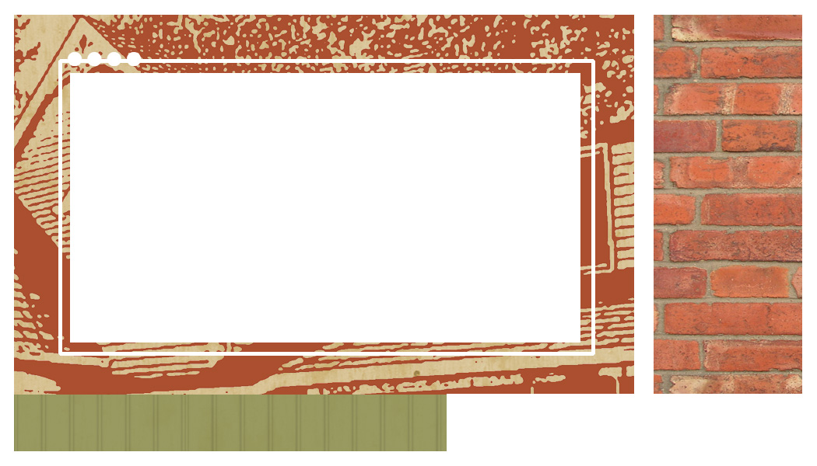
Delete text and type company name
or place logo here.
Delete box or tagline goes here
Place real estate logos here
Delete text and type company name
or place logo here.
Place real estate logos here
Delete text and type company name
or place logo here.
Place real estate logos here
Delete text and type company name
or place logo here.
Place real estate logos here
Delete text and type company name
or place logo here.
Place real estate logos here
Delete text and type company name
or place logo here.
Place real estate logos here
Delete text and type company name
or place logo here.
Place real estate logos here
Delete text and type company name
or place logo here.
Place real estate logos here
Delete text and type company name
or place logo here.
Place real estate logos here
Delete text and type company name
or place logo here.
Place real estate logos here

