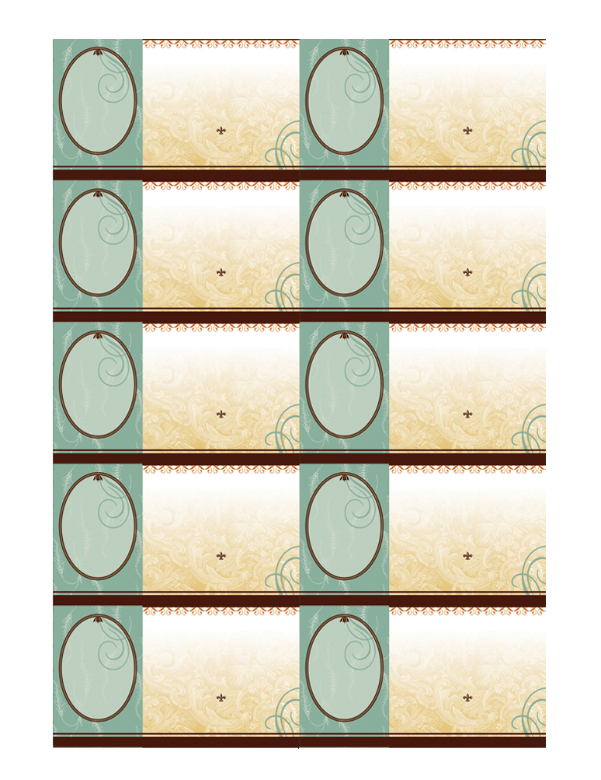
DELETE BOX, PLACE TEXT OR LOGO HERE

Your Name
Here
YOUR TITLE HERE
DELETE BOX, PLACE TEXT OR LOGO HERE
Your Name
Here
YOUR TITLE HERE

DELETE BOX, PLACE TEXT OR LOGO HERE

Your Name
Here
YOUR TITLE HERE

DELETE BOX, PLACE TEXT OR LOGO HERE

Your Name
Here
YOUR TITLE HERE

DELETE BOX, PLACE TEXT OR LOGO HERE

Your Name
Here
YOUR TITLE HERE

DELETE BOX, PLACE TEXT OR LOGO HERE

Your Name
Here
YOUR TITLE HERE

DELETE BOX, PLACE TEXT OR LOGO HERE

Your Name
Here
YOUR TITLE HERE

DELETE BOX, PLACE TEXT OR LOGO HERE

Your Name
Here
YOUR TITLE HERE

DELETE BOX, PLACE TEXT OR LOGO HERE

Your Name
Here
YOUR TITLE HERE

DELETE BOX, PLACE TEXT OR LOGO HERE

Your Name
Here
YOUR TITLE HERE

5555 Street Address, City, ST 55555
www.webaddress.com

5555 Street Address, City, ST 55555
www.webaddress.com

5555 Street Address, City, ST 55555
www.webaddress.com

5555 Street Address, City, ST 55555
www.webaddress.com

Telephone 555.555.5555
Facsimile 555.555.5555
email@emailhere.com

5555 Street Address, City, ST 55555
www.webaddress.com

5555 Street Address, City, ST 55555
www.webaddress.com

5555 Street Address, City, ST 55555
www.webaddress.com

5555 Street Address, City, ST 55555
www.webaddress.com

5555 Street Address, City, ST 55555
www.webaddress.com

5555 Street Address, City, ST 55555
www.webaddress.com

Telephone 555.555.5555
Facsimile 555.555.5555
email@emailhere.com

Telephone 555.555.5555
Facsimile 555.555.5555
email@emailhere.com

Telephone 555.555.5555
Facsimile 555.555.5555
email@emailhere.com

Telephone 555.555.5555
Facsimile 555.555.5555
email@emailhere.com

Telephone 555.555.5555
Facsimile 555.555.5555
email@emailhere.com

Telephone 555.555.5555
Facsimile 555.555.5555
email@emailhere.com

Telephone 555.555.5555
Facsimile 555.555.5555
email@emailhere.com

Telephone 555.555.5555
Facsimile 555.555.5555
email@emailhere.com

Telephone 555.555.5555
Facsimile 555.555.5555
email@emailhere.com

