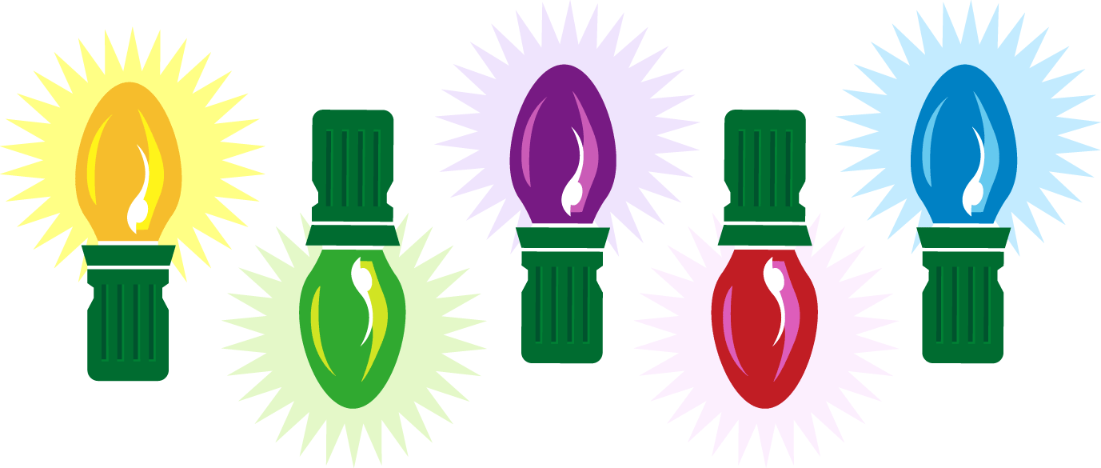  Special Coupon  for Dad  Good for one  Yard Clean-up  with love,  Bobby | Special Coupon  for Dad  Good for one  Movie Night  with love,  Bobby | Special Coupon  for Dad  Good for one  Car Wash  with love,  Bobby | Special Coupon  for Dad  Good for one  Breakfast in Bed  with love,  Bobby | Special Coupon  for Dad  Good for one  Special Dinner  with love,  Bobby
Special Coupon  for Dad  Good for one  Yard Clean-up  with love,  Bobby | Special Coupon  for Dad  Good for one  Movie Night  with love,  Bobby | Special Coupon  for Dad  Good for one  Car Wash  with love,  Bobby | Special Coupon  for Dad  Good for one  Breakfast in Bed  with love,  Bobby | Special Coupon  for Dad  Good for one  Special Dinner  with love,  Bobby

