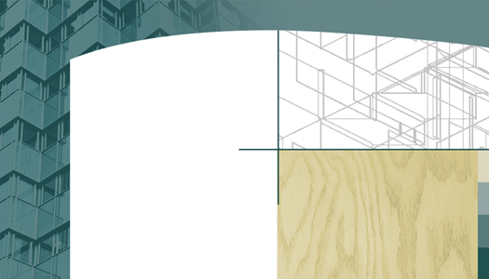

Delete text and insert image here.

Delete text and insert image here.

Delete text and insert image here.

Delete text and insert image here.

Delete text and insert image here.

Delete text and insert image here.

Your Name Here
Your Title
email@emailhere.com
www@webhere.com
ph 555 555.5555
fx 555 555.5555
5555 Street Address
Anytown, USA 55555
Your Name Here
Your Title
email@emailhere.com
www@webhere.com
ph 555 555.5555
fx 555 555.5555

5555 Street Address
Anytown, USA 55555
Your Name Here
Your Title
email@emailhere.com
www@webhere.com
ph 555 555.5555
fx 555 555.5555
Delete box or edit text
5555 Street Address
Anytown, USA 55555
Your Name Here
Your Title
email@emailhere.com
www@webhere.com
ph 555 555.5555
fx 555 555.5555
Delete box or edit text
5555 Street Address
Anytown, USA 55555
Your Name Here
Your Title
email@emailhere.com
www@webhere.com
ph 555 555.5555
fx 555 555.5555
Delete box or edit text
5555 Street Address
Anytown, USA 55555
Your Name Here
Your Title
email@emailhere.com
www@webhere.com
ph 555 555.5555
fx 555 555.5555
Delete box or edit text
5555 Street Address
Anytown, USA 55555
Your Name Here
Your Title
email@emailhere.com
www@webhere.com
ph 555 555.5555
fx 555 555.5555
Delete box or edit text
5555 Street Address
Anytown, USA 55555
Your Name Here
Your Title
email@emailhere.com
www@webhere.com
ph 555 555.5555
fx 555 555.5555
Delete box or edit text
5555 Street Address
Anytown, USA 55555

Delete text and insert image here.

Delete text and insert image here.

Your Name Here
Your Title
email@emailhere.com
www@webhere.com
ph 555 555.5555
fx 555 555.5555
Delete box or edit text
5555 Street Address
Anytown, USA 55555
Your Name Here
Your Title
email@emailhere.com
www@webhere.com
ph 555 555.5555
fx 555 555.5555
Delete box or edit text
5555 Street Address
Anytown, USA 55555

Delete text and insert image here.

Delete text and insert image here.

Delete box or edit text
Delete box or edit text

