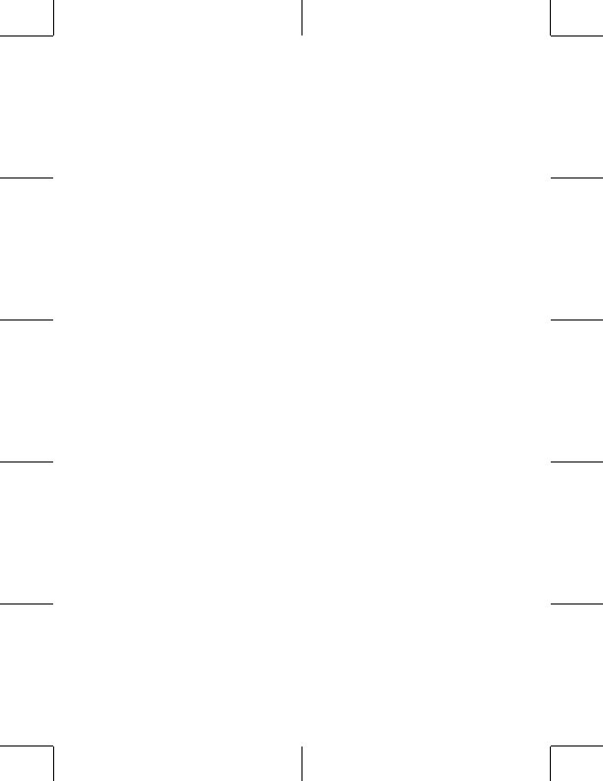
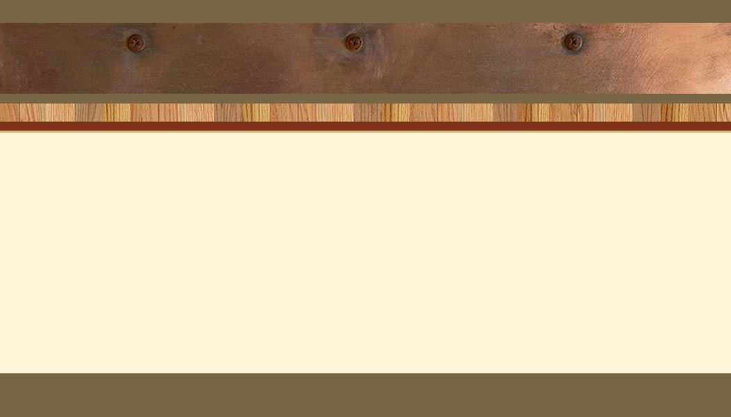
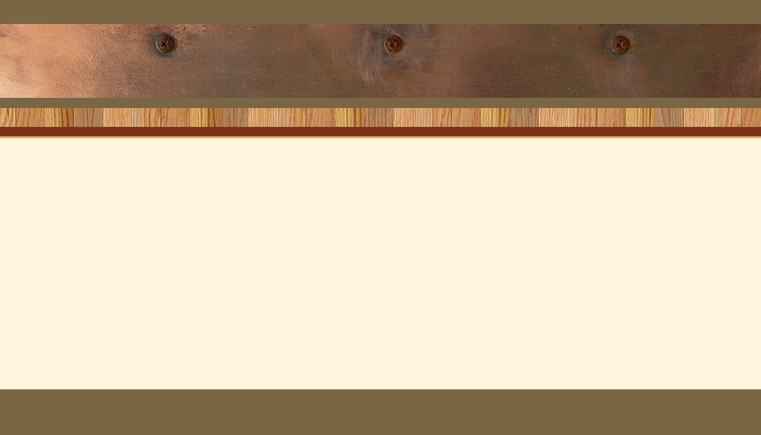
Logo goes here. Otherwise delete this text.

Name, Title
COMPANY NAME HERE
555 Street Address
City, ST 55555
ph 555.555.5555 | fx 555.555.5555

Logo goes here. Otherwise delete this text.

Name, Title

www.webaddress.com

COMPANY NAME HERE
555 Street Address
City, ST 55555
ph 555.555.5555 | fx 555.555.5555

www.webaddress.com
Logo goes here. Otherwise delete this text.

Name, Title
COMPANY NAME HERE
555 Street Address
City, ST 55555
ph 555.555.5555 | fx 555.555.5555

Logo goes here. Otherwise delete this text.

Name, Title

www.webaddress.com

COMPANY NAME HERE
555 Street Address
City, ST 55555
ph 555.555.5555 | fx 555.555.5555

www.webaddress.com
Logo goes here. Otherwise delete this text.

Name, Title
COMPANY NAME HERE
555 Street Address
City, ST 55555
ph 555.555.5555 | fx 555.555.5555

Logo goes here. Otherwise delete this text.

Name, Title

www.webaddress.com

COMPANY NAME HERE
555 Street Address
City, ST 55555
ph 555.555.5555 | fx 555.555.5555

www.webaddress.com
Logo goes here. Otherwise delete this text.

Name, Title
COMPANY NAME HERE
555 Street Address
City, ST 55555
ph 555.555.5555 | fx 555.555.5555

Logo goes here. Otherwise delete this text.

Name, Title

www.webaddress.com

COMPANY NAME HERE
555 Street Address
City, ST 55555
ph 555.555.5555 | fx 555.555.5555

www.webaddress.com
Logo goes here. Otherwise delete this text.

Name, Title
COMPANY NAME HERE
555 Street Address
City, ST 55555
ph 555.555.5555 | fx 555.555.5555

Logo goes here. Otherwise delete this text.

Name, Title

www.webaddress.com

COMPANY NAME HERE
555 Street Address
City, ST 55555
ph 555.555.5555 | fx 555.555.5555

www.webaddress.com


