Your Name
Your Title

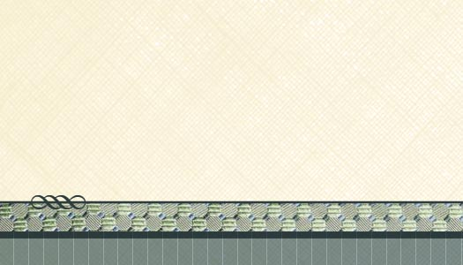
Logo
Goes
here
555 Street Address, Suite 555
City, STATE 5555

555.555.5555 Office • 555.555.5555 Facsimile
your-email-address@url.com

www.your-url-goes-here.com

Your Name
Your Title
Logo
Goes
here
555 Street Address, Suite 555
City, STATE 55555

555.555.5555 Office • 555.555.5555 Facsimile
your-email-address@url.com

www.your-url-goes-here.com

Logo
Goes
here
555 Street Address, Suite 555
City, STATE 55555

555.555.5555 Office • 555.555.5555 Facsimile
your-email-address@url.com

www.your-url-goes-here.com

Your Name
Your Title
Logo
Goes
here
555 Street Address, Suite 555
City, STATE 55555

555.555.5555 Office • 555.555.5555 Facsimile
your-email-address@url.com

www.your-url-goes-here.com

Your Name
Your Title
Logo
Goes
here
555 Street Address, Suite 555
City, STATE 55555

555.555.5555 Office • 555.555.5555 Facsimile
your-email-address@url.com

www.your-url-goes-here.com

Your Name
Your Title
Logo
Goes
here
555 Street Address, Suite 555
City, STATE 55555

555.555.5555 Office • 555.555.5555 Facsimile
your-email-address@url.com

www.your-url-goes-here.com

Your Name
Your Title
Logo
Goes
here
555 Street Address, Suite 555
City, STATE 55555

555.555.5555 Office • 555.555.5555 Facsimile
your-email-address@url.com

www.your-url-goes-here.com

Your Name
Your Title
Logo
Goes
here
555 Street Address, Suite 555
City, STATE 55555

555.555.5555 Office • 555.555.5555 Facsimile
your-email-address@url.com

www.your-url-goes-here.com

Your Name
Your Title
Logo
Goes
here
555 Street Address, Suite 555
City, STATE 55555

555.555.5555 Office • 555.555.5555 Facsimile
your-email-address@url.com

www.your-url-goes-here.com

Your Name
Your Title
Logo
Goes
here
555 Street Address, Suite 555
City, STATE 55555

555.555.5555 Office • 555.555.5555 Facsimile
your-email-address@url.com

www.your-url-goes-here.com

Your Name
Your Title


