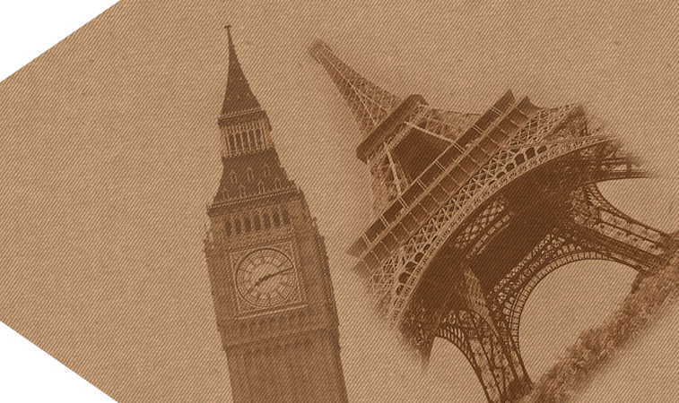 | 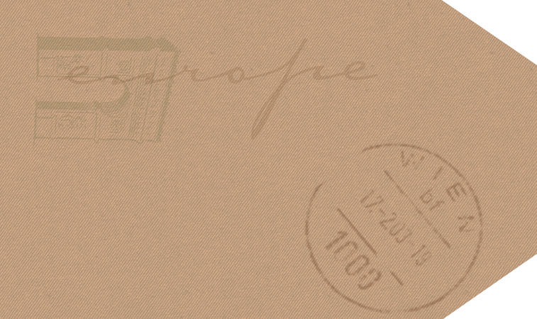 | 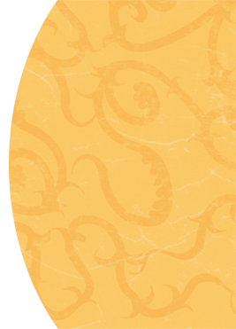
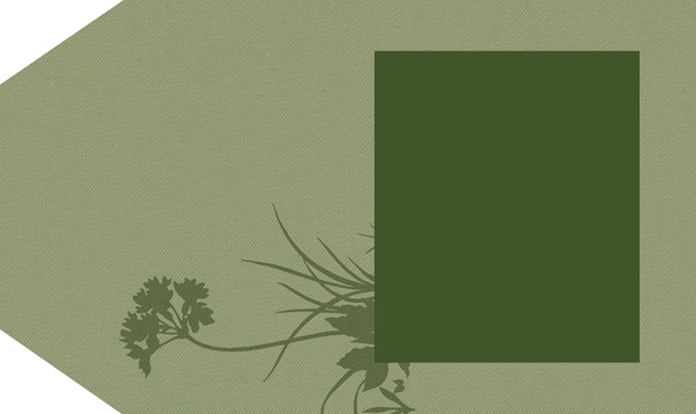  EUROPE  2006 | 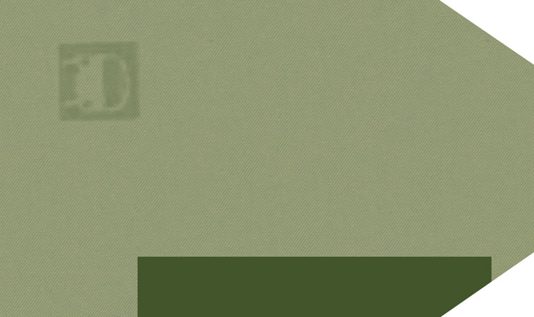
Text Here.

Text Here.
Text here.  Text here.  Place  Photo  Here  Place  Photo  Here  EUROPE  2006  Name  travel  journal  Name  travel  journal  EUROPE  EUROPE |  | Sign-off  Place  Photo  Here  Sign-off  Place  Photo  Here

