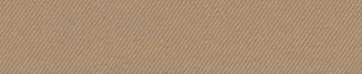  eiffel  arch |  |  |  | 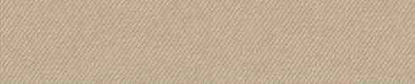 |  |  |  |  |  |  |  | royal
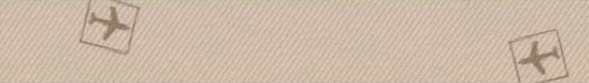


 |  |  |  |  |  |  |  |  |  | Type text here.
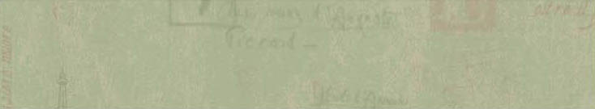
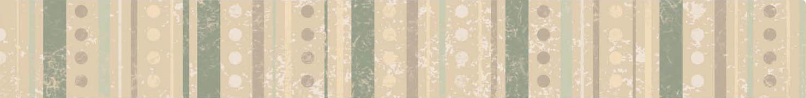


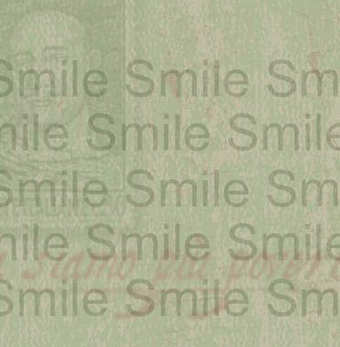
06
NAME  Type  Here  Text  Here.  Text here.  Text  Here.  Type text here.  Type text here.  Type text here.  Type text here.  Type text here.  Type text here.  TEXT  HERE  Text here.  Type text here.  06  Place  Photo  Here  06  TYPE  HERE  TEXT  TYPE  HERE  TEXT |  |  | Place Photo Here.
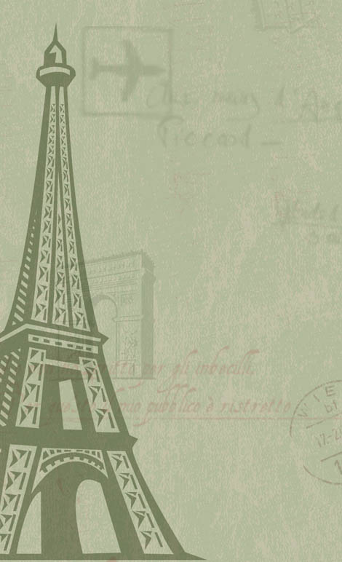
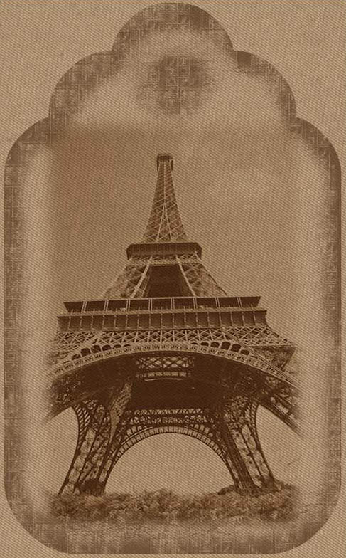
 |  |  |  |  |  |  |  |  |  |  |  | Type journaling here.

