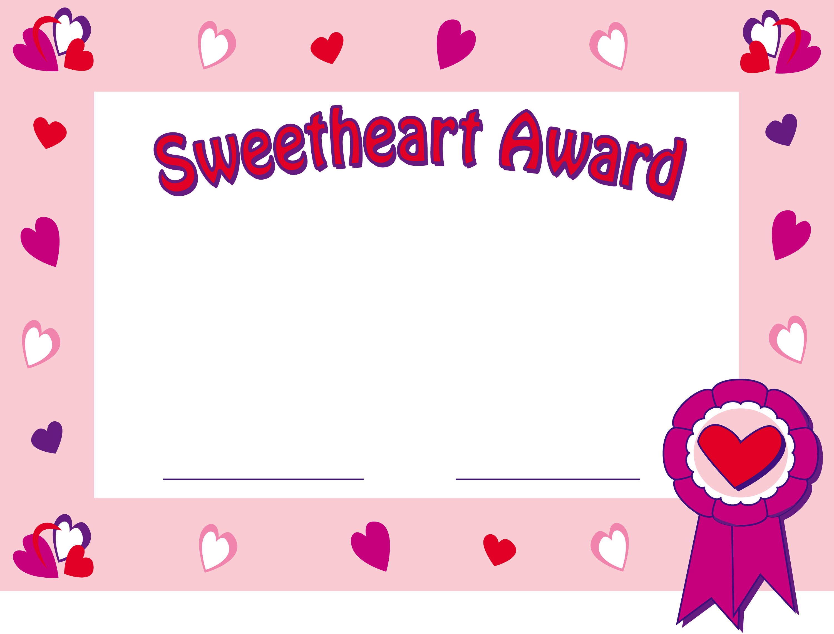
is hereby granted to

(Name Here)

For your kindness and generosity

For your understanding

For your warm-hearted spirit

Presented with love by (your name)
This certificate entitles you to
countless hugs and kisses from me!

